Tuesday 16th June 2026
Dear Parents/Guardians,
We are very much looking forward to our Leavers’ Assembly on 16th July, where the children will have the opportunity to celebrate their time in primary school and share a memorable performance with you.
I have attached links below for the costumes for your child’s role. Please could you purchase something similar to the listed item and ensure it is brought into school by Monday 6th July so that we can begin rehearsals with full costumes.
If you have any questions, please let me know.

Yours Sincerely,

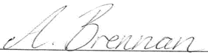

Miss Brennan
Class Teacher

Snow White: AmzBarley Princess Costumes for Girls Fancy Dress for Kids & Toddlers Birthday Themed Party Cosplay World Book Day Costumes Dressing up Clothes 3-4 Years 110 : Amazon.co.uk: Toys & Games

Queen: Wicked Costumed Girls Medieval Tudor Princess Fancy Dress Costume Large (8-10 years) : Amazon.co.uk: Toys & Games

King: Atomvia Kids King Costume Set Red, King Costume Kids, Prince Cloak 80cm with Crown & White Gloves, Velvet Royal Cape for Boys Girls Halloween Carnival Nativity Fancy Dress : Amazon.co.uk: Toys & Games

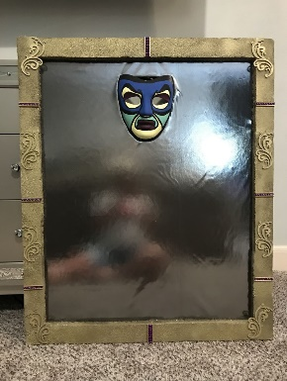
Mirror: This will have to be a home-made costume. Perhaps a large box to wear around the torso. Image for inspiration:

Huntsman: [something similar to this, Robin Hood costumes are perfect but the bow & arrow is not required]. Morph Forest Hero Costume, Archer Costume Kids, Book Character Costumes For Boys And Girls, World Book Day Costumes For Boys 7-9 Years : Amazon.co.uk: Toys & Games

Palace attendants: Morph British Guard Costume, Royal Guard Costume Kids, Kids Dress Up British Soldier, Book Day Costumes For Boys, 3-4 Years : Amazon.co.uk: Toys & Games
Royal Guard Girl 8-10 yrs : Amazon.co.uk: Toys & Games

Tree: Formemory Tree Character World Book Day Costume Set with Full Body Outfit and Headpiece for Storybook Dress Up and Themed Events : Amazon.co.uk: Toys & Games
Matissa Kids Fruits Vegetables Nature costumes Suits outfits Fancy Dress Party Boys Girls (Tree) : Amazon.co.uk: Toys & Games
(Dwarfs) Jockeys: Haloumoning Boys' Medieval Tunic, Children's Cosplay T-Shirts, Costume, Halloween, Renaissance, Viking, Warrior, Knight Tops, Brown, 12-14 Years : Amazon.co.uk: Fashion

Horse: VIROSA Horse Fancy Dress Costume for Boys & Girls (Ages 2–3) | Animal Costume Outfit for World Book Day, School Plays, Halloween & Parties : Amazon.co.uk: Toys & Games

Prospective Queens: any princess ball gown
TTYAOVO Girls Pageant Ball Gowns Kids Chiffon Embroidered Wedding Party Dress Size(160) 11-12 Years 431 Pink : Amazon.co.uk: Fashion
Bookies/Commentator: Kids News Reporter Costume Props Set, Journalist Accessories with Prop Microphone Press Pass Pre Tied, Etc, Complete Set for School Uniform Days, World Book Week, Halloween Parties : Amazon.co.uk: Toys & Games
They will also need a white shirt or waist jacket with smart trousers.

